VOIP lab experiment#14
Creating a time group in the PBX

Installation and Repair of Telecommunications Equipment

Name of student:________________
Group Number:_________________
Date:_________________________

The purpose of the lab is to create a time group for the company in the PBX. A time group indicates the opening / closing time of the company. As well as the start / end day during the week.
- Enter a description
- Enter time to start and closing time of the company operating hours
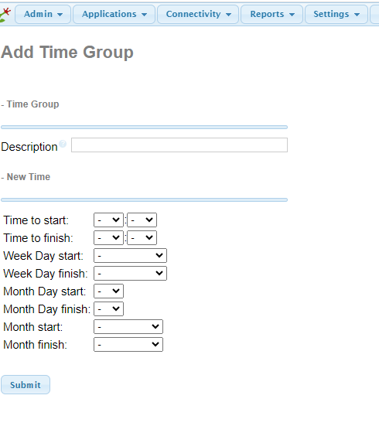

- Enter the week day start and week day finish.
- Click on submit and then apply config

